List Methods
list.sort()
This method sorts the list in ascending order. The original list is updated
Example 1:
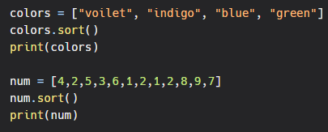
Output:
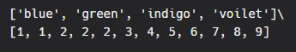
What if you want to print the list in descending order?
We must give reverse=True as a parameter in the sort method.
Example:
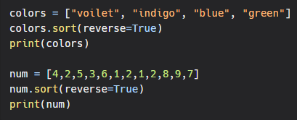
Output:
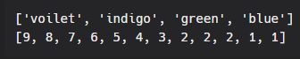
The reverse parameter is set to False by default.
Note: Do not mistake the reverse parameter with the reverse method.
reverse()
This method reverses the order of the list.
Example:
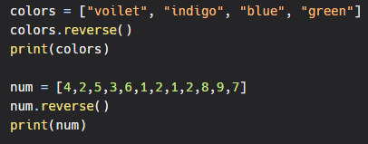
Output:
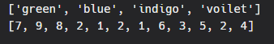
index()
This method returns the index of the first occurrence of the list item.
Example:
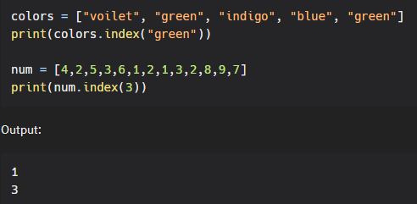
count()
Returns the count of the number of items with the given value.
Example:
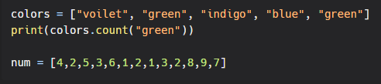

Output:
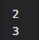
copy()
Returns copy of the list. This can be done to perform operations on the list without modifying the original list.
Example:
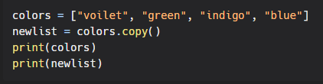
Output:
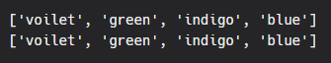
append():
This method appends items to the end of the existing list.
Example:
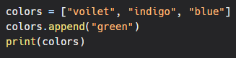
Output:
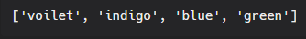

insert():
This method inserts an item at the given index. User has to specify index and the item to be inserted within the insert() method.
Example:
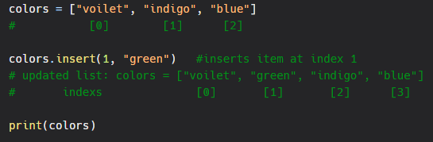
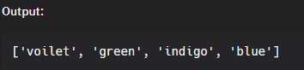
extend():
This method adds an entire list or any other collection datatype (set, tuple, dictionary) to the existing list.
Example 1:
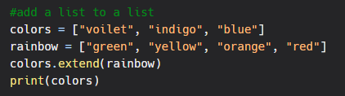
Output:

Concatenating two lists:
You can simply concatenate two lists to join two lists.
Example:
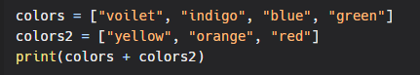
Output:

